FILE DESCRIPTIONS:
Program 1: stdout — Standard Output
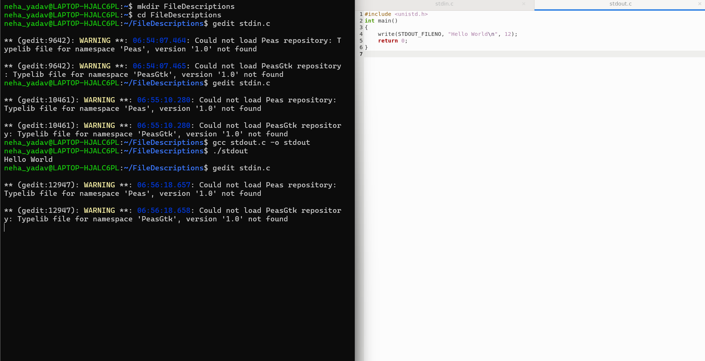
Program 2: stdin — Standard Input
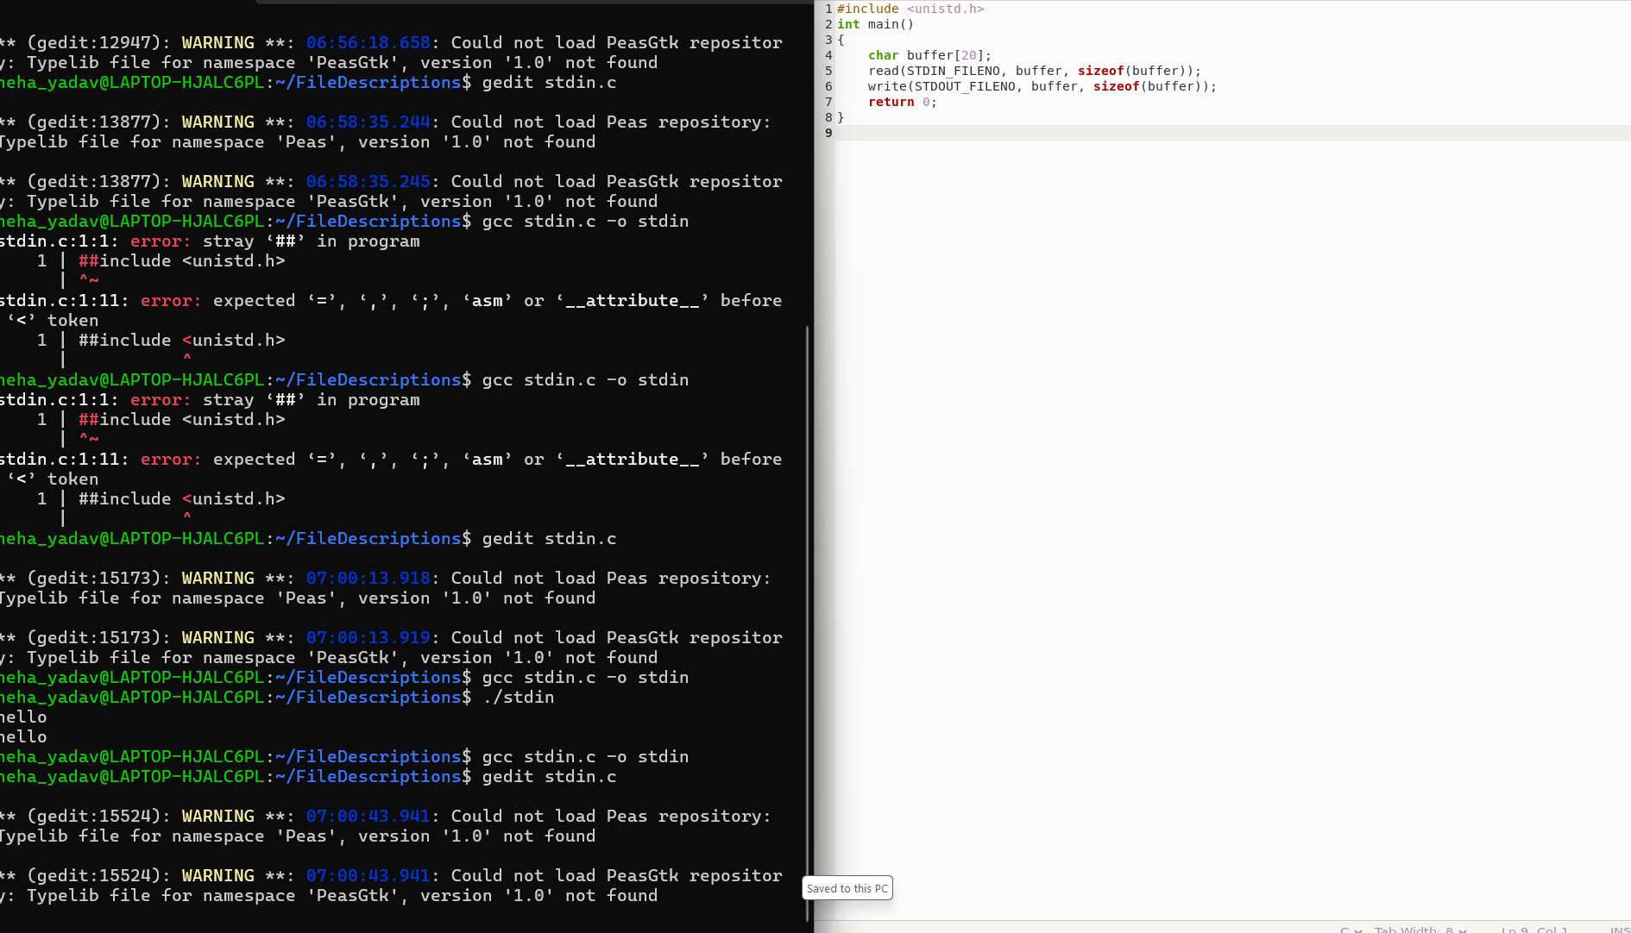
Program 3: Proper stdin + stdout
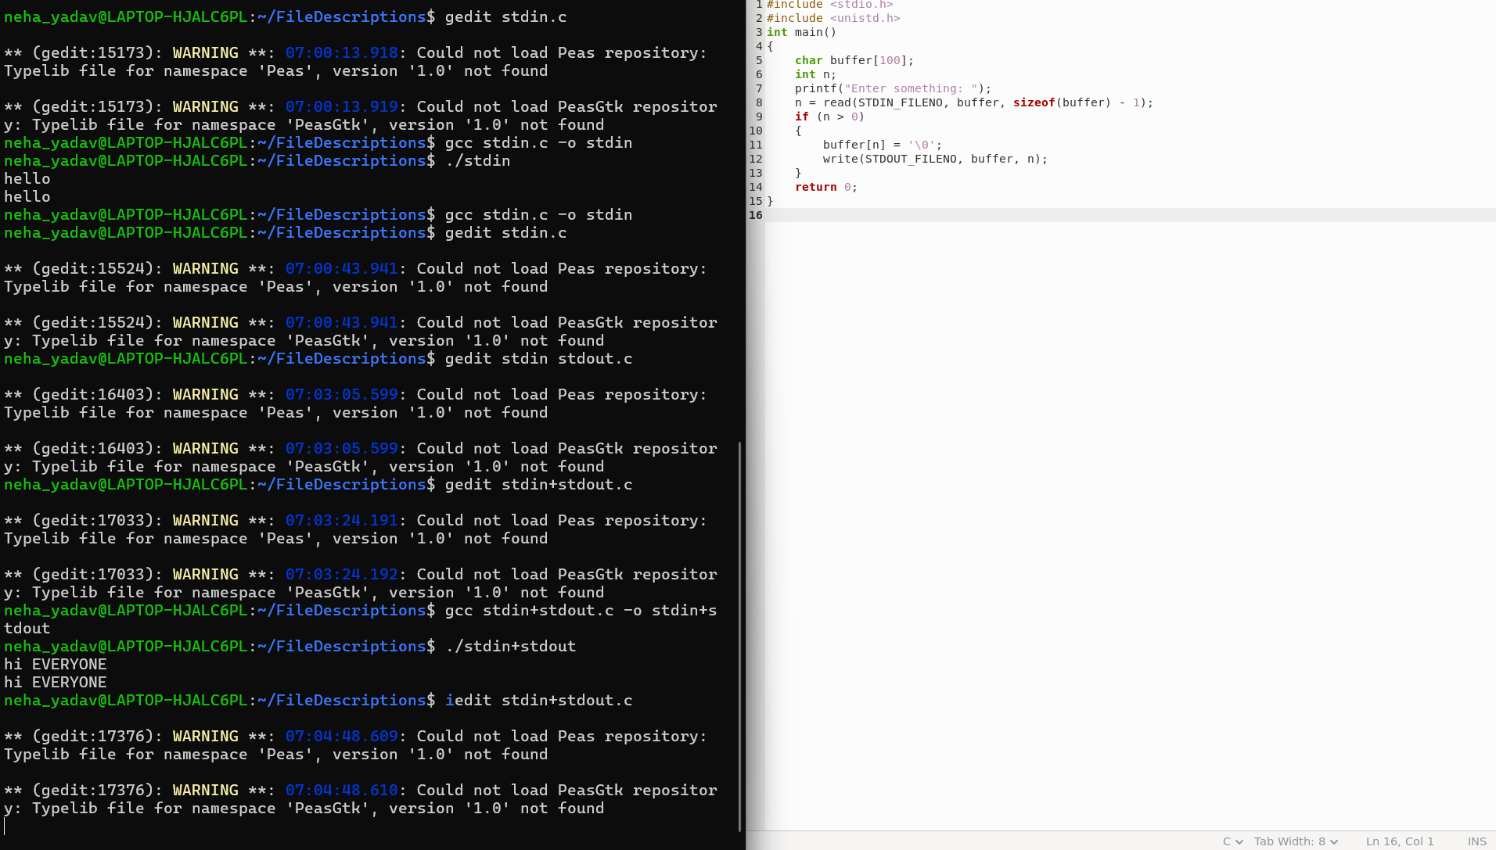
Program 4: stderr — Standard Error
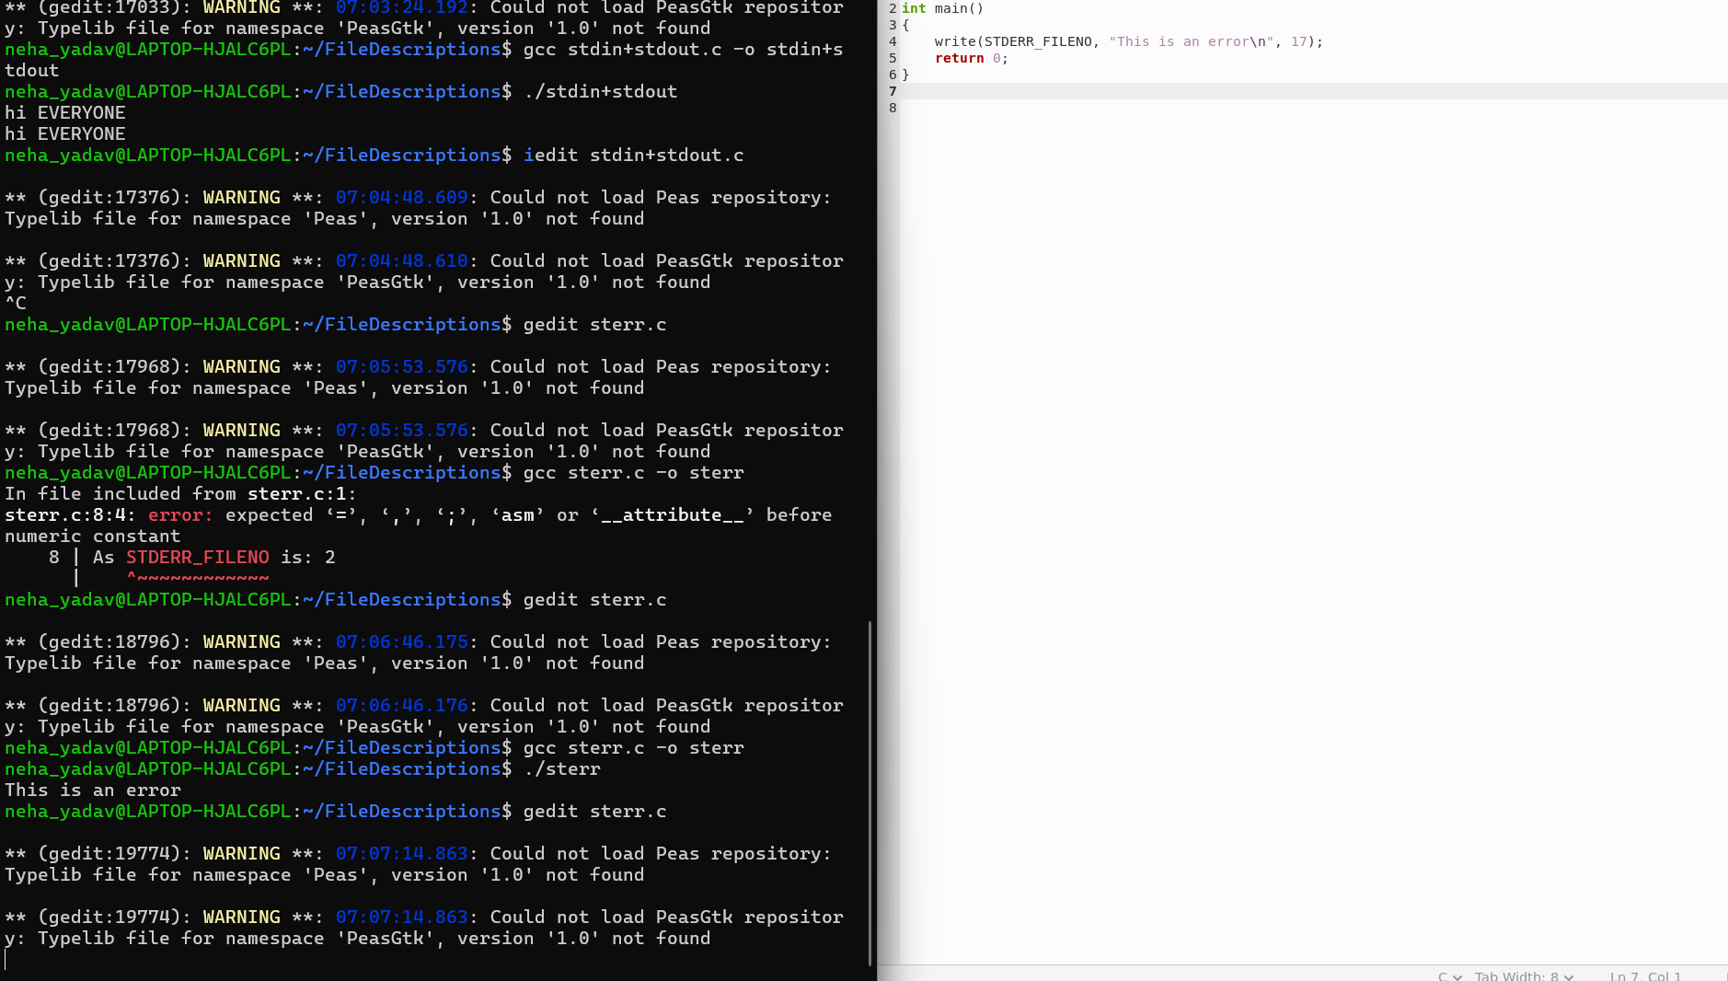
Program 5: stderr for an Actual Error
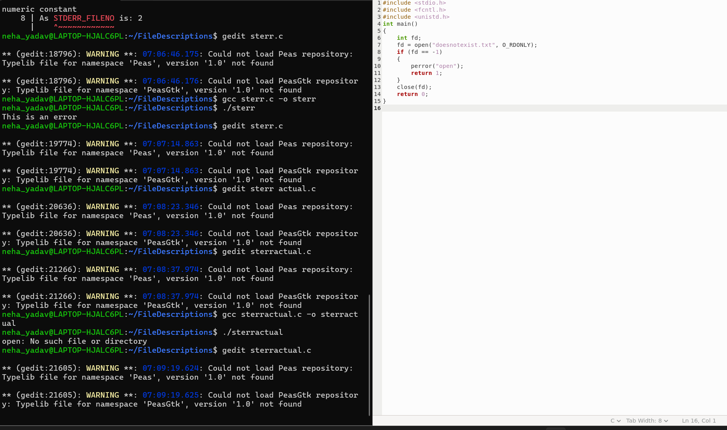
Program 6 Creating file using file descriptor
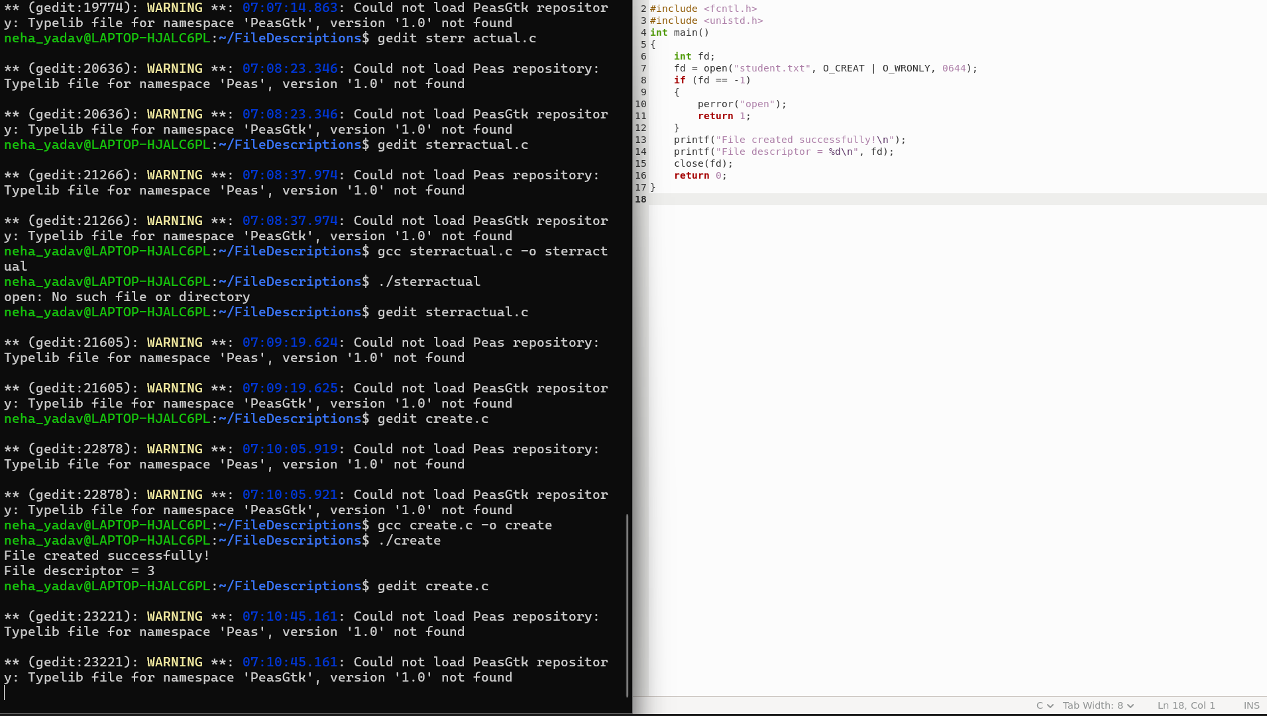
Program 7
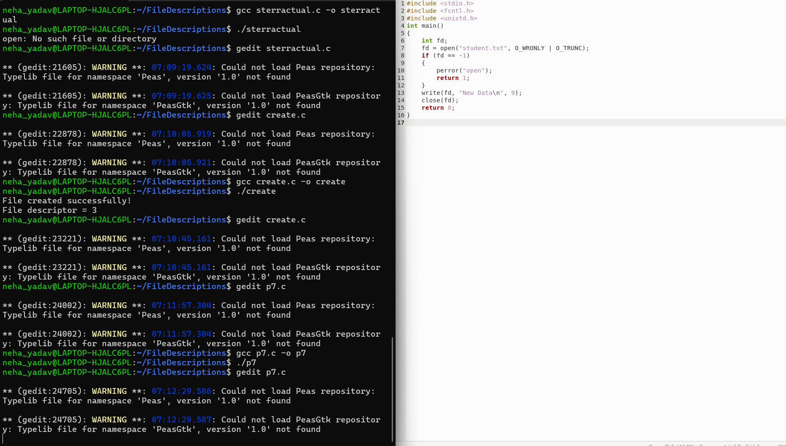
Program 7 - Understand dup()

